Big Ten Minerals Infographic

Purpose
The purpose of this assignment is to familiarize yourself with some important information about the “Big Ten” Minerals and teach it to non-mineralogists. The idea is to create a visual tool (think educational poster) that a high school student could peruse and come away with a basic understanding of and appreciation for these minerals – what they’re made of, how they’re put together, how you would recognize them, why you should care, etc.
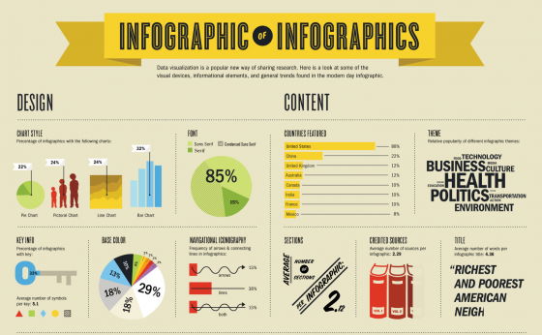
Fig. 1 An infographic of infographics from Visual.ly

In this team activity, you will cooperate with the other member(s) of your team to create a single infographic (Fig. 1) that uses visual cues (graphics/images) along with text to display the formulas for the “Big Ten” Minerals.
The main goal is to create a visual tool that will help your team learn the mineral formulas, become more familiar with their structures, demonstrate knowledge about how to identify them, and research their importance. A complementary goal is to effectively communicate (teach) these concepts to non-mineralogists. Your intended audience is high school students, so design with that in mind.
Be creative and have fun with it!
We will share your completed infographics with Mr. Askander’s high school Earth and Space Science class at New Palestine High School. So keep in mind that your audience will not know a lot about these minerals at this point. You will be teaching them! Keep it simple, clear and concise! We will get feedback from the class and discuss how successful we were at conveying this complex information.

Required content
- Your definition of the term “Big Ten” Minerals
- Chemical make-up – the mineral formulas should be prominently displayed and some explanation of how to interpret these funny letter and number strings should be included
- Crystal structure – some visual representation of the crystal structure of each mineral (or group) should be included, along with some explanation of the different components or shapes presented in the structure (Note: Keep it simple! Cartoon-like depictions are great! They don’t need to be 3D, and you don’t need to show multiple axes.)
- Physical properties – How would you recognize these minerals if you came across them in the field? The key here is to choose the most useful (diagnostic) properties for each mineral to include. Some are important and some are not helpful.
- Geological, economic, and human significance of each mineral
- Uses only credible sources and include citations

Design concepts to guide your work
- Use of visuals/graphics/images used in your infographic must be either: (1) original designs made by you (in google drawing, adobe illustrator, power point, etc.), or (2) images from the internet that fall into public domain, Creative Commons, or fair use categories. Read this page from an IU published textbook on teaching to understand how rules apply to reusing images from the internet.
- Use text only when necessary and useful. Avoid long paragraphs when possible.
- Choose font style, size, and color deliberately. Some tips in this pdf.
- Check out this tutorial on how to make an infographic in 5 easy steps for some more tips and inspiration, and this site specifically on how to get started in STEM infographics. There are so many resources available for learning about how to make an infographic. Google the subject and find your favorite!

Figure 2 on the next page has some very good infographics to inspire you! I had to shrink them down to fit on the page, so you’ll have to zoom in to see the details. All of these infographics are from the website Infogrades.com. Don’t worry – I don’t expect yours to look this polished and professional! Just do your best and try to have fun with it. The goal is to learn and teach, not make a design masterpiece.

Fig. 2 Examples of STEM infographics
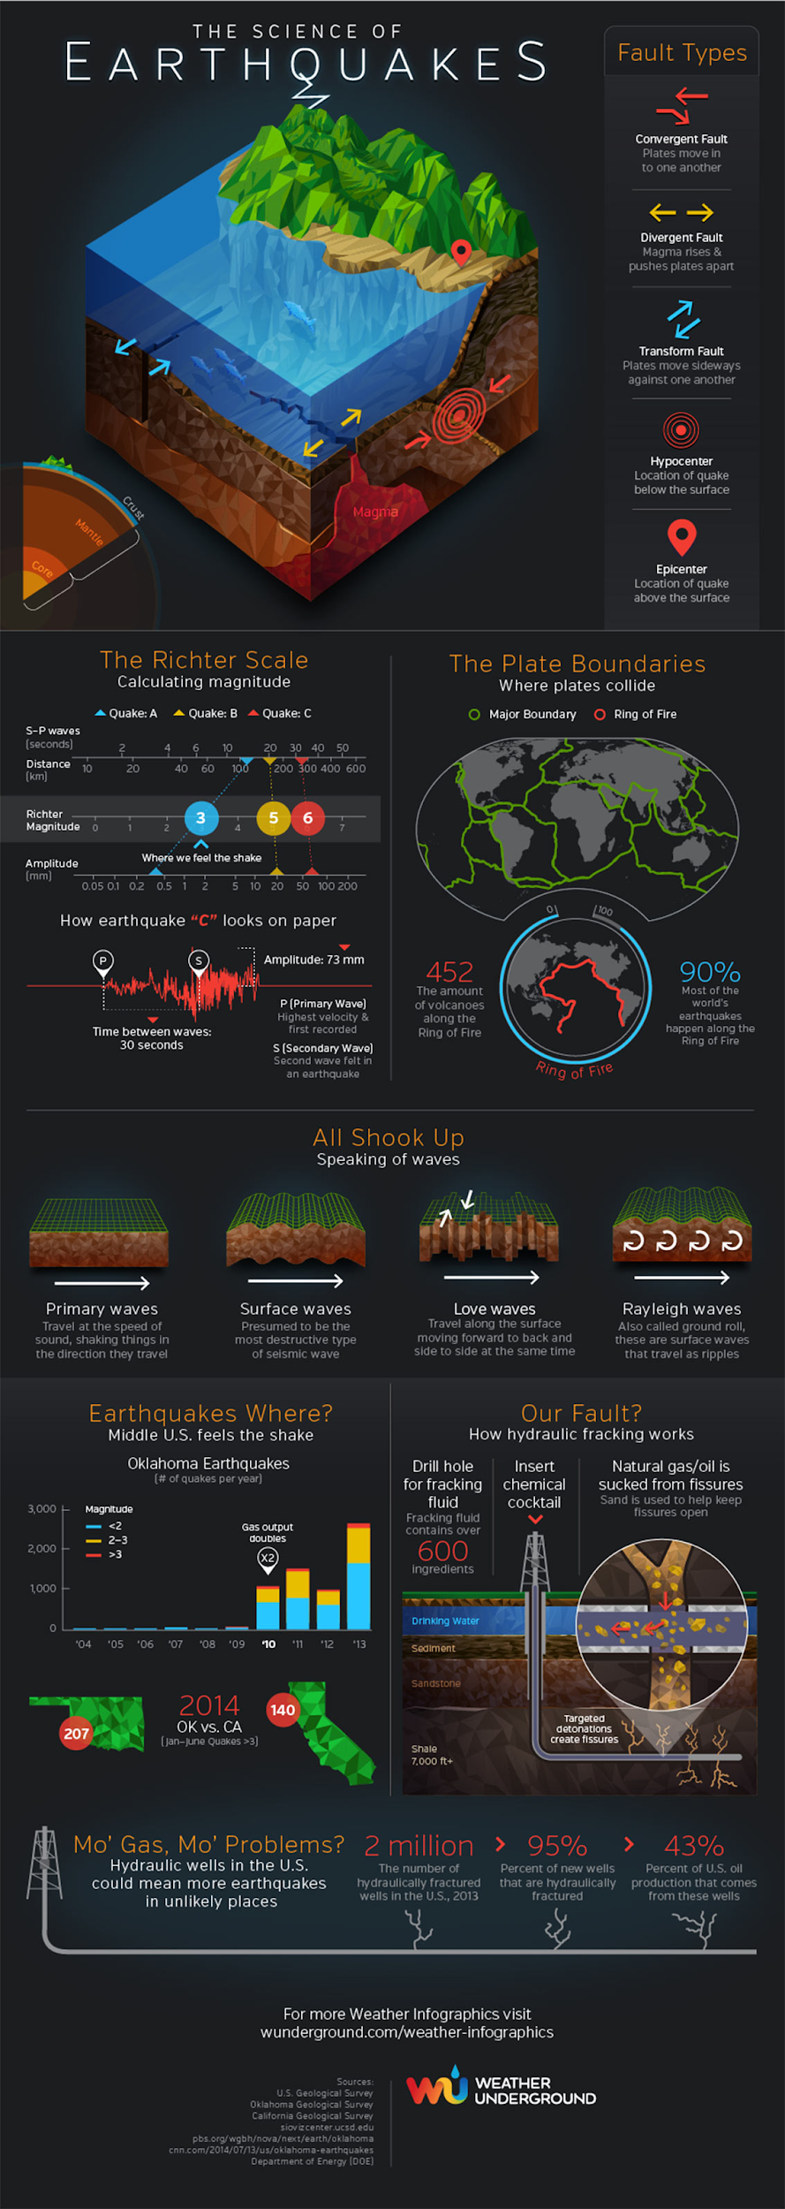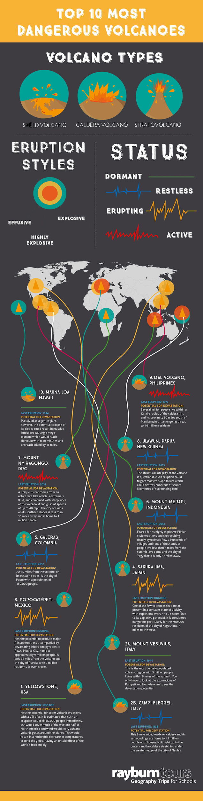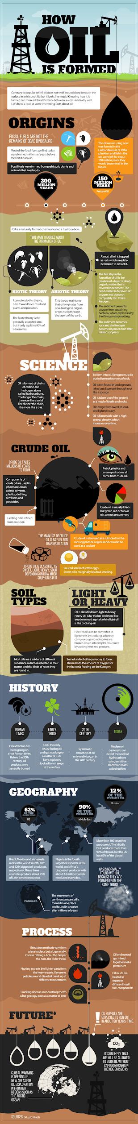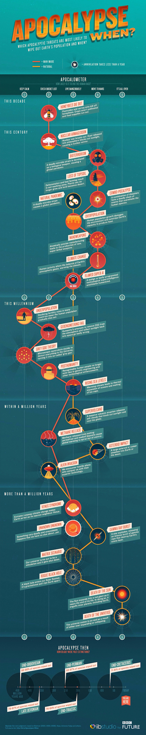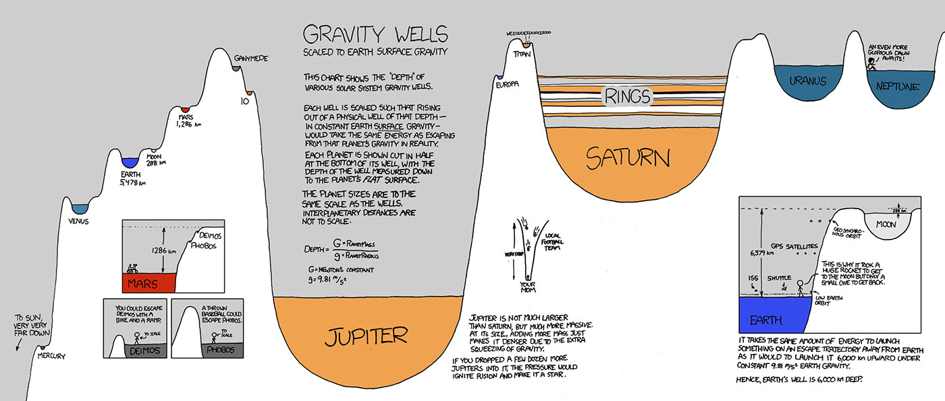

Tasks
- If you haven’t already, read Chapters 1 and 2 in your textbook, then find the “Big Ten” Minerals and their formulas on Table 1.3 in your textbook (p. 15). The rest of the chapter will give you background information on the minerals that you might find useful for this assignment as well.
- Look at some examples of effective infographics.
- Brainstorm with your team via a group discussion on Zoom. Also, decide which tool you will use to create the infographic. Some possibilities include Power Point, Adobe Illustrator, Google Drawing, Google Slides and canva.com. I suggest either Google Drawing, Google Slides, or canva.com because they make it easy to collaborate. Work together with your team to create an infographic that displays the required content listed above about the “Big Ten” Minerals. Remember that the goal is to learn (and teach) about these minerals in a creative and interesting way.
- Submit a team contract.
- The dimensions of the file should be: 1080 x 1080 pixels for a square infographic, 1080 x 566 pixels for a horizontal infographic, or 1080 x 1350 pixels as a vertical infographic.
- Cite all sources you use on the infographic, including the sources of information and any images/graphics that you didn’t create yourself.
- Include the names of all team members who contributed to the infographic on the lower right corner.
- Every team member should submit a copy of the infographic as a pdf, jpg, or png file through Canvas by the due date.
- Every team member should submit a self- and group-assessment through canvas as an additional file.

Criteria

Big Project #1 Rubric
Criteria | Exemplary | Satisfactory | Developing | Pts.
Images/ Graphics | The visualization formats chosen make the information presented easy for the viewer to understand the information.  (20 pts.) | The visualization formats chosen showcase the data, but some may make it difficult for the viewer to understand the points.  (10 pts.) | Other visualization formats should be chosen to best showcase the data presentation for the viewer.  (5 pts.) | 20
Text | All text used is essential to the goal of the infographic, complements and enhances the images, and uses a font that elevates the overall design. (20 pts.) | Most text used is essential to the goal of the infographic. It complements the images and the font is appropriate to the overall design and readable. (10 pts.) | Extraneous or insufficient text is used. It does not complement images and the font is inappropriate or unreadable (5 pts.) | 20
Content | Contains all of the required information (described above) about the “Big Ten” Minerals (60 pts.) | Contains more than half of the required information (described above) about the “Big Ten” Minerals (40 pts.) | Contains less than half of the required information (described above) about the “Big Ten” Minerals (20 pts.) | 60
Grammar and spelling | No grammar or spelling errors. (5 pts.) | A few grammar or spelling errors. (3 pts) | Many grammar or spelling errors. (0 pts.) | 5
Size |  | File is one of the approved sizes (5 pts.) | File is not one of the approved sizes. (0 pts.) | 5
Citations | Full citations for all sources used are included. (5 pts.) | Only some sources are cited.  (3 pts.) | No citations to sources used are included.  (0 pts.) | 5
Group Contract | Completed (10 pts.) | Partially completed (5 pts.) | Not submitted (0 pts.) | 10
Self and Group Assessment | Completed (10 pts.) | Partially completed (5 pts.) | Not submitted (0 pts.) | 10
 |  |  |  | 135

